New Knowledge Based Home Learning Activities
Good morning everyone ☺
Here are the learning tasks for you to do this week.
- There is a sheet of key facts for maths on Shapes to read.
- There is also a sheet of key facts on Skara Brae to read.
- There is a creative task also for you to do.
Then, after you have read the knowledge sheets, we would like you to have a go at two Kahoot! quizzes on what you have learnt. These are great fun and you do them on your laptop, tablet or phone. Here are instructions on how to play:
- Google kahoot.it and click on the link below.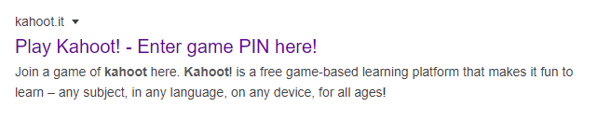
- Enter the Game PIN number
Maths: 05973704
Hadrian’s Wall : 77462582

- Join the game by entering your first name (no nicknames please!) and pressing ‘OK, go!’

- Your teacher will be able to see who has played the quiz and your scores so make sure you have a go and try your best!
Reading
- We have also set some new books on Serial Mash. Read the second chapter of these and complete the quiz. Read Sapphire for more of a challenge.
Emerald | Sapphire
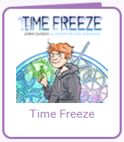 | 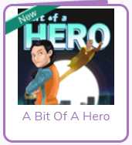
- Keep up to date with all of the interesting things that are happening in the world by following First News.
TT Rockstars
As well as all the fantastic reading you will do please remember to go on TT Rockstars. Your times tables are so important for your development and progress in Year 6 (If you can’t access these contact your teacher for a username and password)
There are also two spelling activities to have a go at (further down the page), and a quiz on these which has been set as a ‘to do’ on Purple Mash.
This way, we will be able to see how well you are doing on the quizzes!
Happy quizzing!

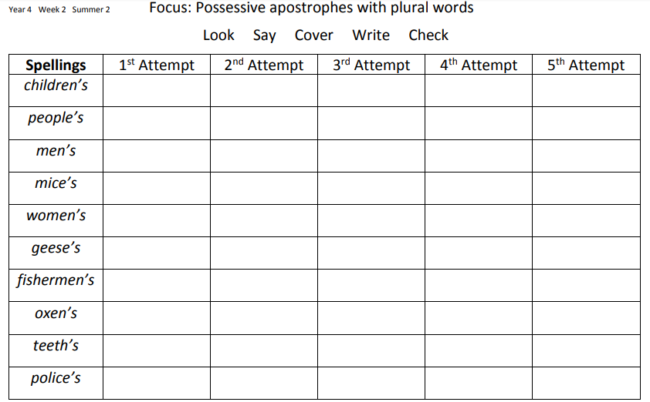

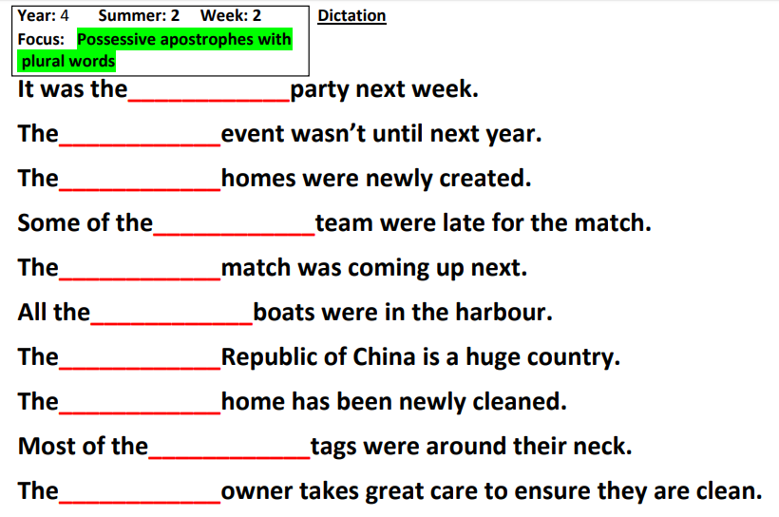

Answers on the next page!

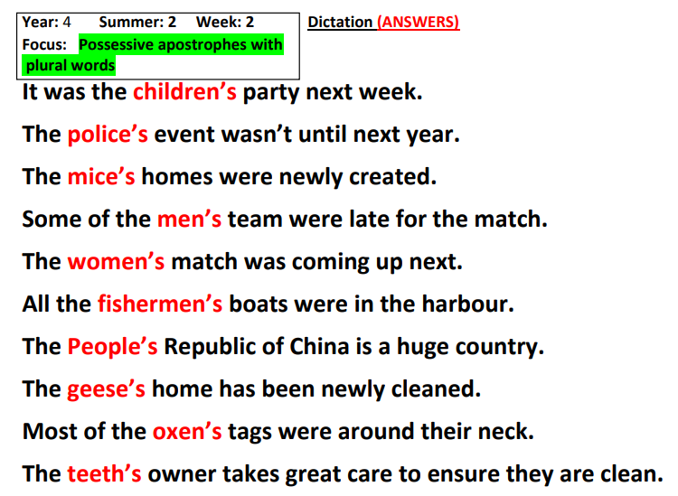
Maths – Shapes
There are 2 types of shapes 2D (2 dimensional) and 3D (3 Dimensional).
2D (2 dimensional) Shapes
2D shapes are flat (they have one face)
We group them based on:
- The number of their sides
- The length of their sides
- The angles (or vertices) they have
e.g. A square has 4 sides of equal length
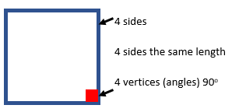
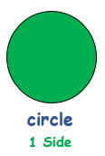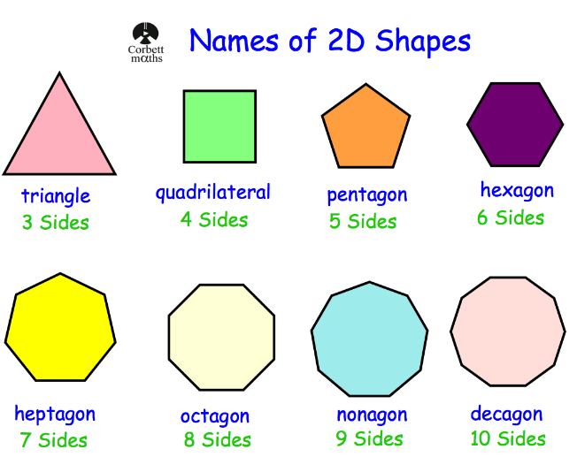
Triangles – 3 sided shapes (4 types)
- Equilateral Triangle – All sides same, All angles same
- Isosceles Triangle – Two sides same, Two angles same
- Right-Angled Triangle – Contains one right-angle
- Scalene – All sides different, all angles different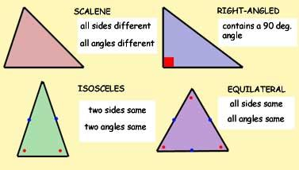
Quadrilateral – 4 sided shape
There are many different types of Quadrilaterals
Different length sides
Different internal angles
Different lines of symmetry
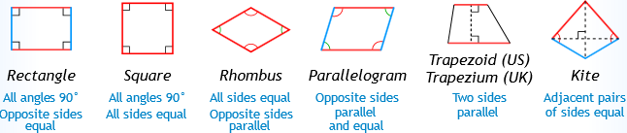
3D shapes
- More than one face (face is the flat part of the shape)
- The edges are the lines where the 2 faces meet
- The vertices are the points where 2 or more edges meet
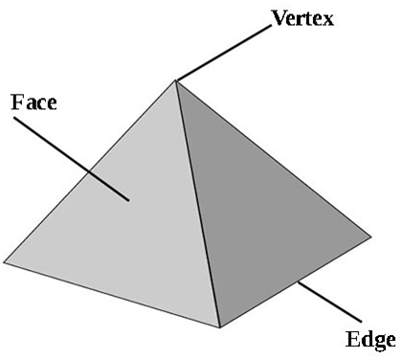
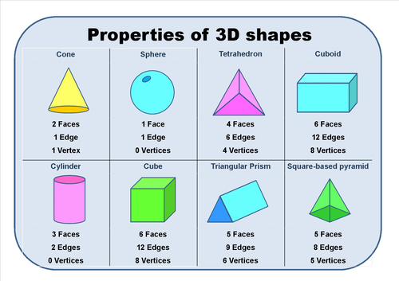

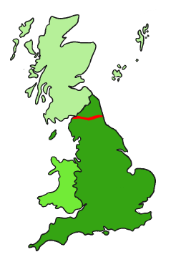
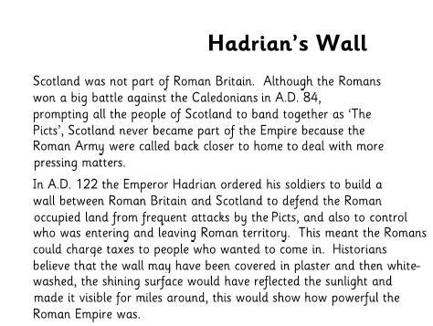

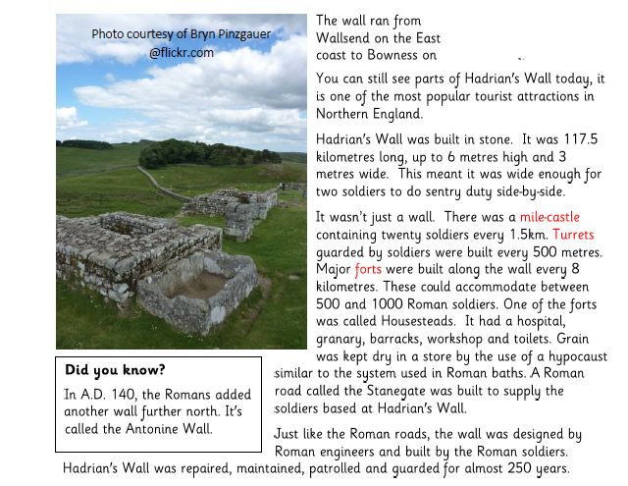

Creative Task-
Lockdown is becoming less strict, people can go on holiday again. It’s nearly time for the summer holidays! Imagine you can catch an aeroplane to anywhere in the world!
Where would you go?
Write a piece describing what that place is like, what you can:
See, Hear, Smell, Touch and for a bonus points if you include Taste
Photos of some places have been given as an example
Amazon Jungle
Rio De Janeiro, Brazil
The Antarctic
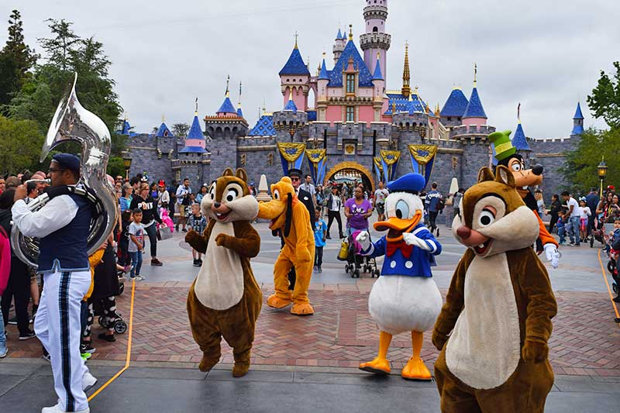
Disneyland

