CC: MH, CF, KSL, KP
Minutes of Y4 Team Meeting – 27th April 20 (1hour)
Wellbeing check-ins
Discussion around any concerns/issues
- Claire to send NFER data email from Kirtsy to update target tracker data.
- Update MEPs and send 2 SEND kids email (Mon & Fri)- Claire to find where MEPs are.
- Task A: Millie
Task B: Callum
Task C: Claire
- Start writing reports: deadline TBC (around May), aim for 10 a week.
- Check planning on SharePoint; all on correct format, Claire to check Topic planning format.
- Deadline for next week’s home learning- WEDNESDAY

Working from home Year Group overview
Year Group: 4
Week Beginning: 27.04.2020
Example overview:
Teacher to plan: | Focus: | Task: | Deadline: | To be marked- yes or no
Mr Findlater | Maths | Purple Mash – 2do... 2d Shape x2 (Name 2D shape, 2D shape perimeters), Multiplication, Monster Multiplication | Friday 1st May | No
 | Topic | Purple Mash – 2do… Romans, Romulus and Remus | Friday 1st May | Yes
 | Computing | Purple Mash – 2do…Coding, Gibbon: Shapes | Friday 1st May | No
Miss Hardy | Well Being - DOJO | Children to create a den within the homes and read their favourite book or create a piece of artwork. | Chn not expected to spend more than 1 hour on this. | No- but children are encouraged to share ta photograph with their teacher.
 | Creative Task - DOJO | Children to design and create artwork using recycled milk bottles.  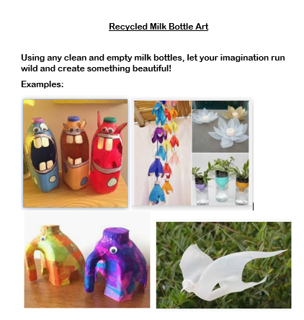 | Chn not expected to spend more than 1 hour on this. | No- but children are encouraged to share their artwork with their teacher.
Mrs Boerder | Reading Focus: Prepare a ‘reading challenge/interesting task or competition for the week.  Read an extract/story and upload to dojo. - Across the Roman Wall - First part.  Signpost to read First News weekly | Challenge:  Phone/FaceTime/Zoom someone and read a story to them. I read to my grandchildren on FaceTime. Read a comic. Or a graphic novel. Read this online book about the Coronavirus. It’s written specially for children and answers lots of questions https://nosycrowcoronavirus.s3-eu-west-1.amazonaws.com/Coronavirus-ABookForChildren.pdf  What is the most unusual place you can read? Make sure it’s somewhere safe! Mrs Hainsworth has challenged the staff to do this! This is your reading challenge for this week. As you can see – there are 8 challenges. See how many you can complete and let us know how you get on. Read this funny poem.. .https://www.youtube.com/watch?v=TRuz6fadjEw  It was the Queen’s birthday last week! Go online and read about why she has 2 birthdays every year! Read First News or a different newspaper. You can do this online if you don’t have one in the house. Log on to Purple Mash and explore Serial Mash. There are lots of books for you to choose from, with quizzes and other activities to do after each chapter! | Ongoing through the week. | No – but children should be encouraged to respond to the challenge via dojo.

Template for Weekly Dojo:

Good morning everybody.
As previously shared, we have reviewed our approach to the home learning tasks. We would like the children to complete 5 tasks per week as well as Reading daily, and these can be carried out on the day/times that suit you. We have split the tasks between Purple Mash and Class Dojo and will review how well this works after 2 weeks. We are here to support you and your child – If you have any questions, queries or feedback, please do not hesitate to get in touch.
You are all doing a fantastic job. We are very much aware that some of you are trying to work from home, support children of different ages and run a household with success and positivity. We have adapted this to support parents and pupils in these unprecedented times. Please continue to focus on your own well-being and continue to keep safe at home.
Have a great week,

Wb:  27.4.2020  Home Learning  Year 4  Purple Mash | Maths, computing and topic tasks have been set as ‘To dos’  Maths: Focus – Shapes. There are a number of activities set covering 2d shapes.  Computing: Focus – Coding. Using Gibbon Section, children will complete the Shapes Activity. This will be broken down into sections, you will have to use your coding skills to change the shapes, your maths work should help you with this. TIP: Use the videos and hint section if you get stuck! If you find that too tricky, choose an activity in Chimp level and complete that instead.  Topic: Romans. Create a booklet on the brothers who founded Rome - Romulus and Remus. This website has some useful information https://www.ducksters.com/history/ancient_rome/romulus_and_remus.php  Daily Times Tables: There is a daily times tables activity to complete  Please remember to try your best and have a go at the activities. Please don’t feel pressured or anxious about completing all tasks as we are well aware that home-life does not look the same in every house.
Class Dojo | Well-being task for the week is: Children to create a den and read their favourite book or create a piece of artwork.  Creative task for the week is: To create artwork using recycled milk bottles.  You could use one of these ideas, or think of your own:  It would be great to share your photos on dojo portfolio!
Reading | Challenge:  Phone/FaceTime/Zoom someone and read a story to them. I read to my grandchildren on FaceTime. Read a comic, or a graphic novel. Read this online book about the Coronavirus. It’s written specially for children and answers lots of questions https://nosycrowcoronavirus.s3-eu-west-1.amazonaws.com/Coronavirus-ABookForChildren.pdf  What is the most unusual place you can read? Make sure it’s somewhere safe! Mrs Hainsworth has challenged the staff to do this too! This is your reading challenge for this week. As you can see – there are 8 challenges. See how many you can complete and let us know how you get on. Read this funny poem.. .https://www.youtube.com/watch?v=TRuz6fadjEw " Be careful not to laugh your socks off!  It was the Queen’s birthday last week! Go online and read about why she has 2 birthdays every year! Read First News or a different newspaper. You can do this online if you don’t have one in the house. Log on to Purple Mash and explore Serial Mash. There are lots of books for you to choose from, with quizzes and other activities to do after each chapter!

