Class Dojo | 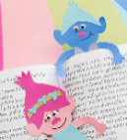  Well-being Monday 1st June 2020 is Global Parents Day. Let’s get busy showing our parents/carers how much we appreciate everything they do for us. Here is a list of suggestions to help you do this.  - Write and illustrate a poem – an example is included to help but you will have lots of your own ideas for this too  - Bake a cake  - Make or help make a meal  - Create a music playlist of a parent’s favourite songs  - Make a memories book filled with the best things you have done together  - Create a piece of artwork using your parent’s favourite colours and make a frame for it  - Or an idea of your own

Phone/FaceTime/Zoom someone and read a non-fiction to them.  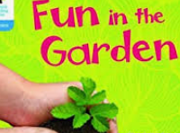  I would Zoom my sister-in-law and read to her about growing vegetables. | Read a graphic novel.  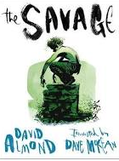  This is my favourite (and it’s on sale on Amazon!) | Read about how to look after an exotic animal you dream of owning (but probably never will!)  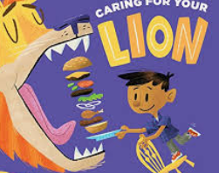  I would research looking after a lion.
Read a book in a home-made den. It should be in a different place to the other one.  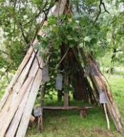  I would make mine outside! | This is your reading challenge for this week. As you can see – there are 8 challenges. See how many you can complete and let us know how you get on. | Read something that you wouldn’t normally – you might surprise yourself!  I haven’t read many biographies so I would probably start there.
Read something online about a famous person you admire from the past.  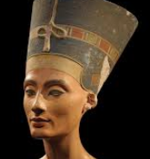  I would research Queen Nefertiti. | Read First News or a different newspaper.  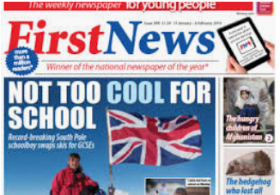  You can do this online if you don’t have one in the house. | Read a book you know you are going to enjoy!  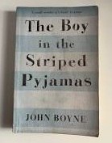  This is one of my favourites!

