Wb: 4.5.20.  Home Learning  Year 6  Purple Mash | Maths, computing and topic tasks have been set as ‘To dos’  Maths: Focus – Probability. Most/least likely, fractions, decimals, percentages equivalents. Create a ‘2quiz’ on probability or topic of your choice (just for fun)  Computing: - Focus – Coding. Gibbon x2 challenges. Gibbon free code (you create the code)  Science: focus – Diet, exercise and lifestyle. 1. Watch bbc class clips/research  https://www.bbc.co.uk/bitesize/topics/zrffr82  2. Download/print or write on health & growth exercise word doc (answers attached)  3. Complete Purple Mash science ‘to dos’ – ‘What happens when’… ‘Healthy eating plan’  Daily Times tables: There is a daily times table activity check to complete.  Please remember to try your best and have a go at the activities. Please don’t feel pressured or anxious about completing all tasks as we are well aware that home-life does not look the same in every house.
Class Dojo  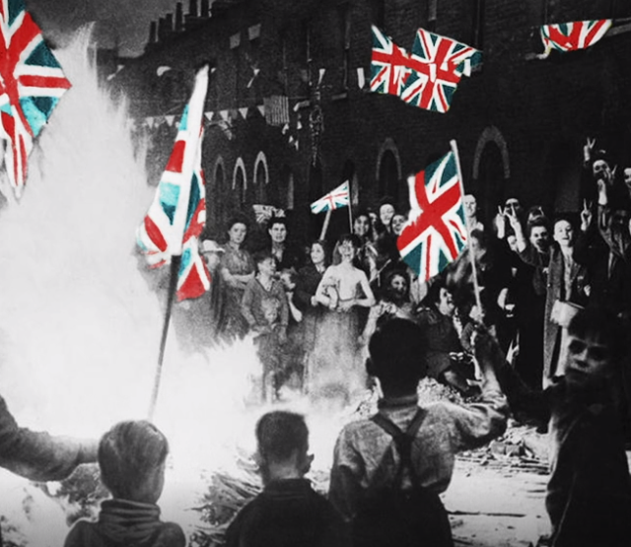 | 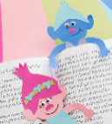  Well-being task for the week: VE Day – 75th Anniversary 8th May 2020  Research and make notes - VE Day: https://www.bbc.co.uk/teach/class-clips-video/history-ks2-ve-day/z7xtmfr  Talking Point: Why did people come together on VE Day to celebrate?  How might the people have felt on May 8th 1945? Think about why there would be many mixed feelings.  Activity: Using the video images, look closely at the scenes with the celebrating crowds and imagine you are in it. Create a soundscape - list the sounds you can hear! Then draw your own version based on the list of sounds you have created. Make it colourful and include the colours red, white and blue. Once completed, post on Class Dojo Portfolio.  Plan a VE party menu. First research rationing of food using this link - http://www.primaryhomeworkhelp.co.uk/war/rationing2.html  You now know the types of food that would have been available. Plan a menu based on 1945. Now think about a modern VE day party and plan a menu using food of today.  It would be great if you and your family had a VE party at home using the food you have planned. Remember homemade red, white and blue bunting would be perfect to add a patriotic feel to the day. Take pictures and have a lovely day!
Reading | Challenge: ‘Submerged City’  - Study the picture. Discuss it with someone or talk aloud to yourself about it. Then answer the questions 1-13. Extension: write 5 more questions for someone else to answer about The Submerged City.  - Write definitions for the words. Extension: use these in a short piece of writing about what it would be like to live there.  - Add –cial or –tial to the ends of the words so they are spelled correctly. Extension: find more –cial and –tial words (hint: look in your Y6 spelling book). Then make up some mnemonics (memory joggers’) to help you remember how to spell the three tricky words.  - Complete the SPAG activities around different types of nouns and prepositions. Extension: look up some other collective nouns, e.g. a murder of crows, a flamboyance of flamingos. Can you make up some of your own?  - Imagine you are the author of a story called ‘The Submerged City’. Have a go at writing the opening of the story, or the climax, or the ending… Or – write the whole story! We would love to read some of them!

