New Knowledge Based Home Learning Activities
Good morning everyone ☺
Here are the learning tasks for you to do this week.
- There is a sheet of key facts for maths on all topics to read.
- There is also a sheet of key facts on Julius Caesar to read.
- There is a creative task also for you to do.
- You may do any coding of your choice.
Then, after you have read the knowledge sheets, we would like you to have a go at two Kahoot! quizzes on what you have learnt. These are great fun and you do them on your laptop, tablet or phone. Here are instructions on how to play:
- Google kahoot.it and click on the link below.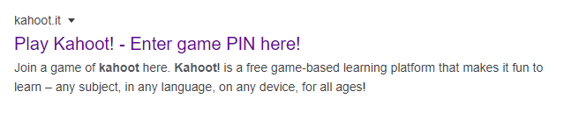
- Enter the Game PIN number
Maths: 04095754
Julius Caesar: 05946533

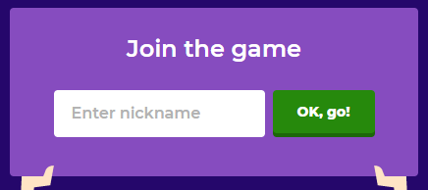
- Join the game by entering your first name (no nicknames please!) and pressing ‘OK, go!’

- Your teacher will be able to see who has played the quiz and your scores so make sure you have a go and try your best!
Reading
- We have also set some new books on Serial Mash. Read the fourth chapter of these and complete the quiz. Read Sapphire for more of a challenge.
Emerald | Sapphire
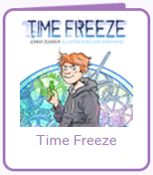 | 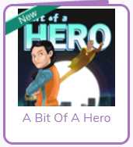
- Keep up to date with all of the interesting things that are happening in the world by following First News.
TT Rockstars
As well as all the fantastic reading you will do please remember to go on TT Rockstars. Your times tables are so important for your development and progress in Year 6 (If you can’t access these contact your teacher for a username and password)
There are also two spelling activities to have a go at (further down the page), and 4 quizzes which have been set as a ‘to do’ on Purple Mash.
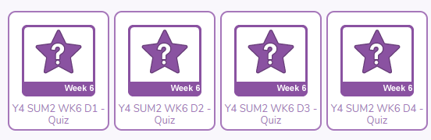
This way, we will be able to see how well you are doing on the quizzes!
Happy quizzing!

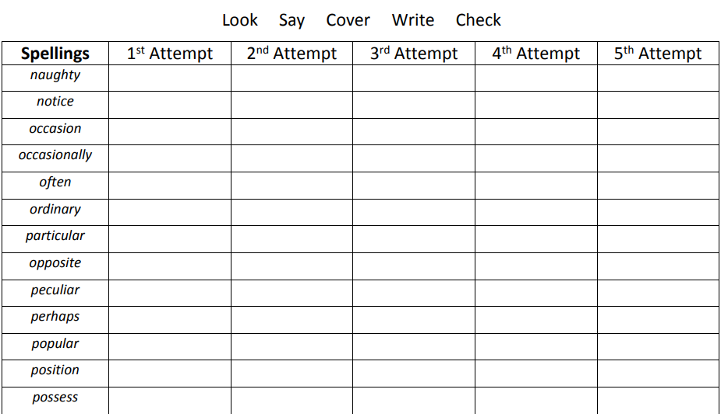
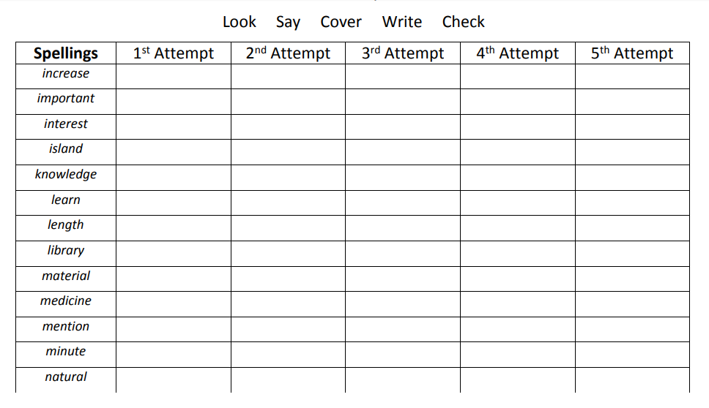

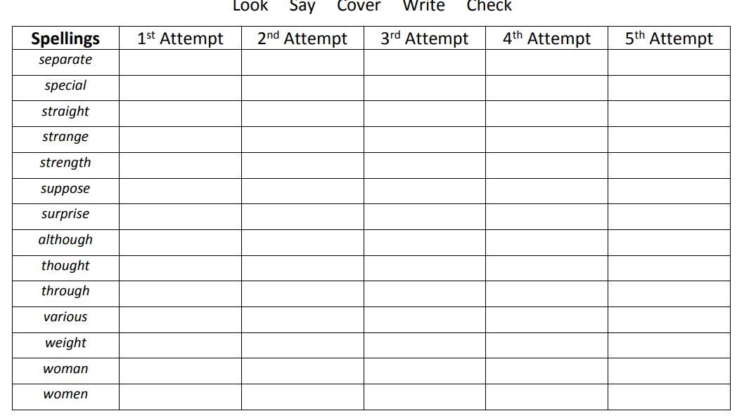
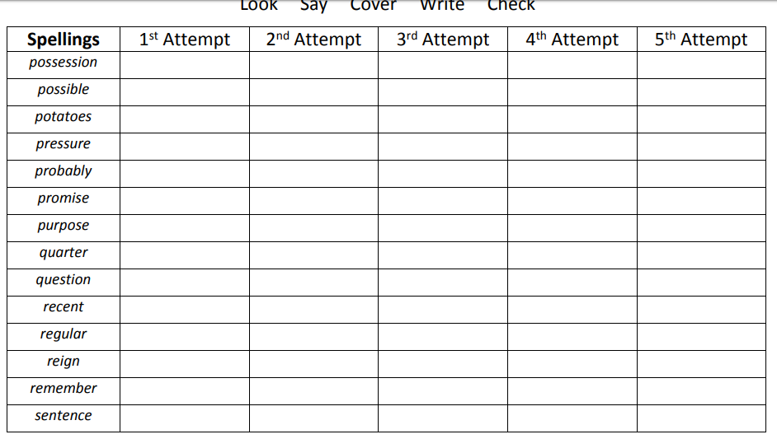
Use the space on the next page to write your own sentences, this week, using any of the words above.

Maths – Shapes
There are 2 types of shapes 2D (2 dimensional) and 3D (3 Dimensional).
2D (2 dimensional) Shapes
2D shapes are flat (they have one face)
We group them based on:
- The number of their sides
- The length of their sides
- The angles (or vertices) they have
e.g. A square has 4 sides of equal length
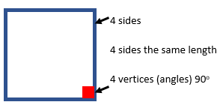
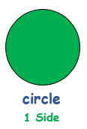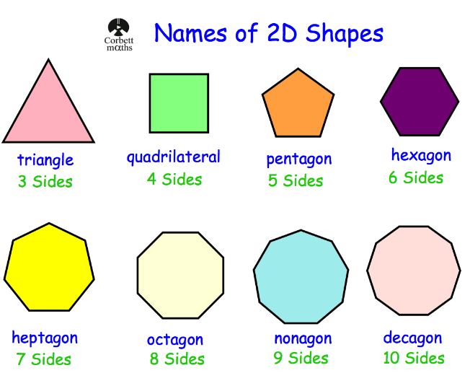
Triangles – 3 sided shapes (4 types)
- Equilateral Triangle – All sides same, All angles same
- Isosceles Triangle – Two sides same, Two angles same
- Right-Angled Triangle – Contains one right-angle
- Scalene – All sides different, all angles different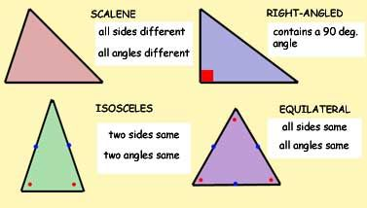
Quadrilateral – 4 sided shape
There are many different types of Quadrilaterals
Different length sides
Different internal angles
Different lines of symmetry
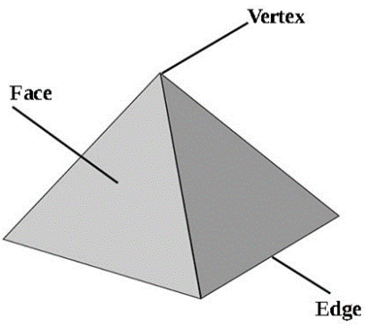
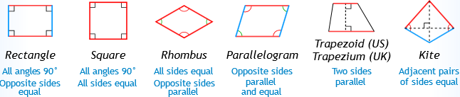
3D shapes
- More than one face (face is the flat part of the shape)
- The edges are the lines where the 2 faces meet
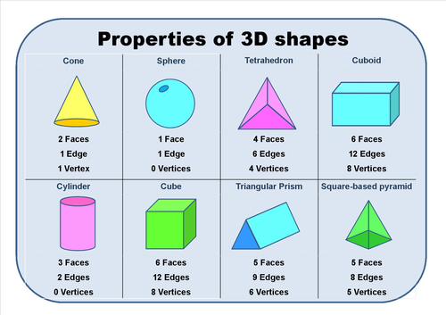
- The vertices are the points where 2 or more edges meet

Describing Co-ordinates
Grids are a way of showing information. They are square.
We normally use 2 sides of the grid to describe where a co-ordinate is, these are the Axes.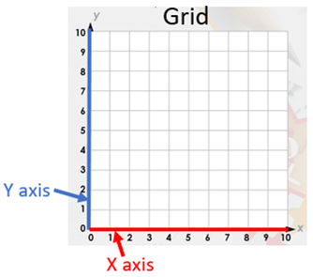
X Axis
The first axis is the X axis. This runs along the bottom of the grid. This has numbers along the bottom at equal spaces. In our examples they will go from 0 -10.
Y Axis
The Y axis runs up the side of the grid. This also has numbers at equal spaces.
Numbers
The co-ordinates tell us the place on the grid. They are 2 numbers inside brackets.
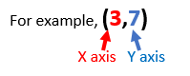
Left number = X axis
Right number = Y axis.
A way to remember this is ‘Along the corridor and up the stairs’
Look for the first number on the X axis then follow the line up the grid. Do the same with the Y axis number, where the lines cross is your co-ordinate.
Our example is 3 along the X axis and 7 up the Y axis. The co-ordinate is where their lines cross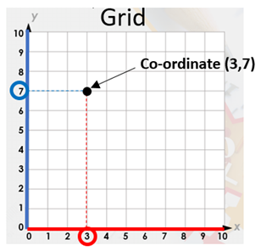
Adding/Subtracting Money
To add money:
- Put the numbers in a vertical column, aligning the decimal points
- Add each column of digits, starting on the right and working left. If the sum of a column is more than ten, "carry" digits to the next column on the left.
- Place the decimal point in the answer directly below the decimal points in the terms.
To subtract money:
- Put the numbers in a vertical column, aligning the decimal points.
- Subtract each column, starting on the right and working left. If the digit being subtracted in a column is larger than the digit above it, "borrow" a digit from the next column to the left.
- Place the decimal point in the answer directly below the decimal points in the terms.
- Check your answer by adding the result to the number subtracted. The sum should equal the first number.
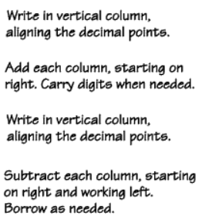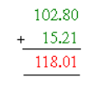
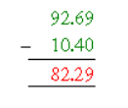

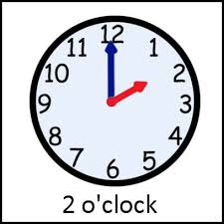
Telling Time
O’clock - When the big hand is on the 12 it is o’clock or on the full hour
We know what the hour is by where the small hand is.
e.g. The big hand on the 12 nd the small hand on the 2 = 2 o’clock
In digital this would be 02:00

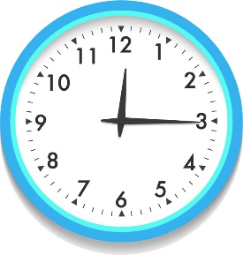
Quarter past - When the big hand is on the 3 it is quarter past the hour.
The hour is on the little hand e.g. quarter past 12
In Digital this would be 12.15 because it is 15 minutes past the hour

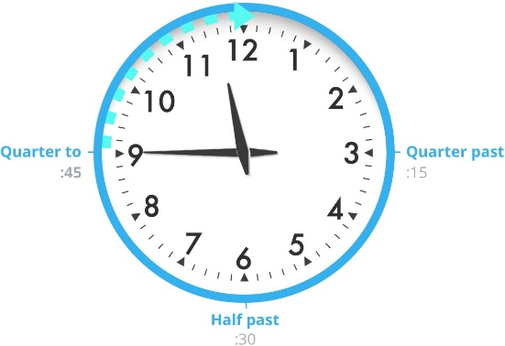
Quarter to – When the big hand is on the 9 it is quarter to the hour.
The little hand is between 2 numbers – it's the next number in a clockwise direction
e.g. quarter to 12 (big hand on 9 the little hand between 11 and 12)
Digital clock this would be 11:45

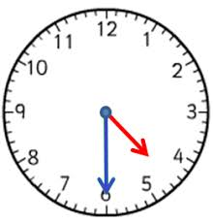
Half past - When the big hand is on 6 it is half past the hour.
The little hand is between 2 numbers – it's the first number in a clockwise direction
e.g. Half past 4 (big hand is on 6, little hand is between 4 and 5)

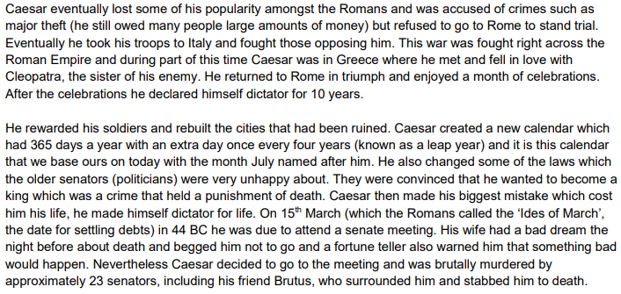
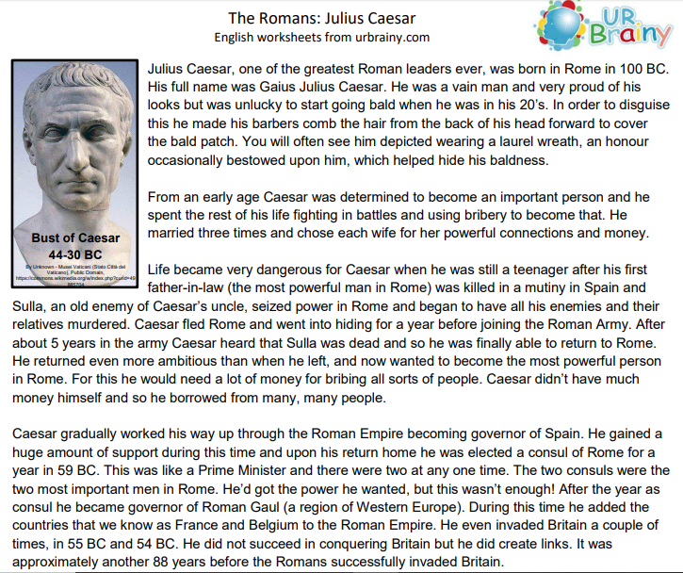
Creative Task
School over lockdown is almost finished.
Do a creative piece of writing about your time learning at home during lockdown.
Write a diary entry reflecting on how you feel about your time at home
Must include:
> Best part
> Worst part
> How you felt when you realised you’d be learning at home
> How you feel now that you should be back in school in September
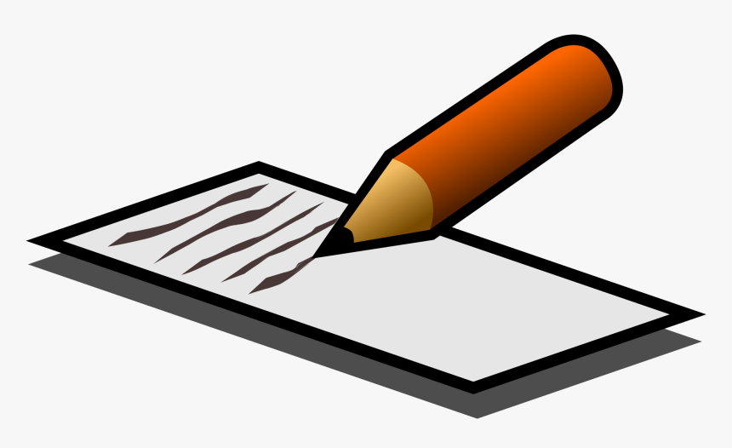
If you don’t want to do a diary entry you can write it in a different form: a poem or even a shopping list.

