Working from home Year Group overview
Year Group: 4
Week Beginning: 8.6.2020
Overview:
Teacher to plan: | Focus: | Task: | Deadline: | To be marked- yes or no
Mrs Boerder | Maths | Times tables  This is the Monster Multiplications  Maths: Focus – Time  Can you help Mr Wolf tell the time? Complete the sentences with the correct time. 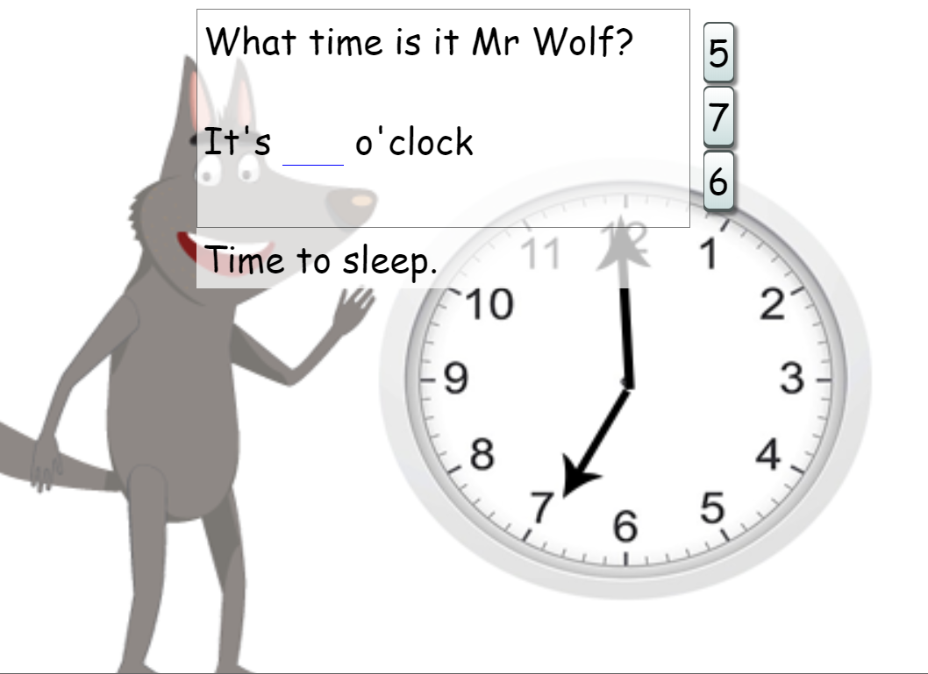  Try these first.......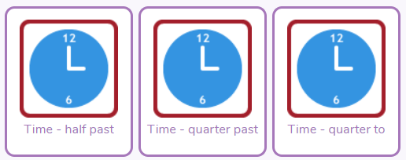  Then try these.......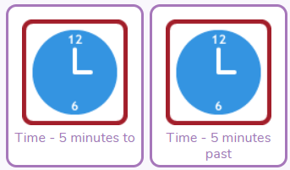  Now try all of the times mixed up!......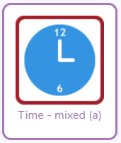 | Friday 12th June | Brief comment/  symbol
 | Topic | Purple Mash -  Romans:  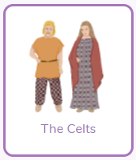2do- Read the information then write about the Celts  Science:  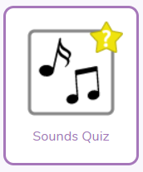You might want to watch the sounds slideshow again before you try this! 2do- Play the sounds quiz . Can you get full marks? | Friday 12th June | Yes
 | Computing | Purple Mash – Coding,  Haunted Scene - Learn to move spooky sprites!  Switching background – Learn how to create a switch that remembers | Friday 12th June | Brief comment/  symbol
Mr Findlater | Well Being - DOJO | Well-being task for the week is:  Have a go at Meditation !  Why? It...  - Helps you to enjoy the present moment  - Teaches breathing techniques that decrease anxiety and increase focus  - If do for a long time it can change your brain so you are calmer  Try one of this routine designed for children. If you like it there are lots more online.  https://www.youtube.com/watch?v=Bk_qU7l-fcU  ﷟HYPERLINK "https://www.youtube.com/watch?v=R-BS87NTV5I" | Chn not expected to spend more than 1 hour on this. | No- but children are encouraged to share a photograph with their teacher.
 | Creative Task - DOJO | 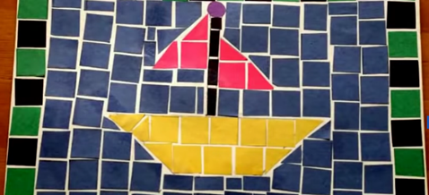  Create your own Mosaic  These video shows you how... https://www.youtube.com/watch?v=3yQ4yQOyPrk and https://www.youtube.com/watch?v=s3Lxyqn42eU  - The Romans used to make Mosaics, these are one of the things they brought to the UK  - Your mosaic can be of anything you like, something that has helped you in lockdown or copy a picture from a book  - You can use coloured paper or cut out pictures from old magazines/newspapers  - If you don’t have any coloured paper to use at all you can draw something  Send your teacher a picture! | Chn not expected to spend more than 1 hour on this. | No- but children are encouraged to share a video with their teacher.
Joint | Reading Focus: Prepare a ‘reading challenge/interesting task or competition for the week.  Read an extract/story and upload to dojo.  Signpost to read First News weekly | Challenge:  Chapter 3 of these books has been set as a 2do. Choose one to read. Emerald Sapphire Treasure’s Island A Horde of Ravens Complete the online multiple-choice quiz for your chosen book. Read First News or a different newspaper. You can do this online if you don’t have one in the house.  Listen to the book that your teacher is reading on dojo. Leave a message in the comments telling your teacher what you think of the book so far..... The reading challenges have changed slightly this week! The first 2 have been set as 2dos on Purple Mash, which means that we would like you to make sure you have completed them. You can then see how many of the other challenges you can complete. Try something new! Choose something you wouldn’t normally read. So, if you like stories, choose a book of facts etc. You might discover something you really enjoy!  Use this link to have a go at the BBC Bitesize daily lesson on inference: https://www.bbc.co.uk/bitesize/articles/zf7qmfr Vocabulary is very important! Play a game of Scrabble with your family or friends. If you don’t have it at home you can play it online here: https://www.scrabblegames.info/play/scrabble-online Log on to Serial Mash in Purple Mash. Choose any one book and read the first chapter (Emerald and Sapphire are normally the best categories) OR Read the next chapter of the book that you chose last week | Ongoing through the week. | Some- the first 2 brief comment or symbol –children should be encouraged to respond to the other challenges via dojo.

Purple Mash | Maths, computing and topic tasks have been set as ‘To dos’  Maths: Focus – Time  Can you help Mr Wolf tell the time? Complete the sentences with the correct time.  Try these first.......  Then try these.......  Now try all of the times mixed up!......  Coding,  Learn to move spooky sprites!  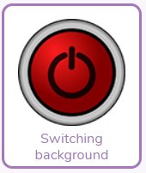Learn how to create a switch that remembers  TIP: Use the videos and hint section if you get stuck!  Topic -  Romans:  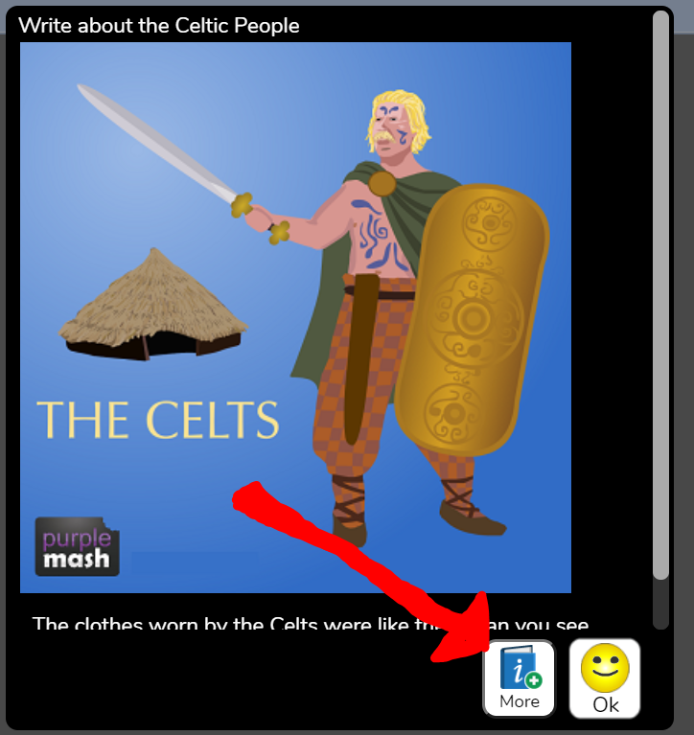  Read the information then write about the Celts. You will need to click on the ’more’ button shown by the red arrow to show the information, and you can do extra research online if you want!  Science:  You might want to watch the Sounds slideshow again before you try this! 2do- Play the sounds quiz. Can you get full marks?  Daily Times Tables:  This is the Monster Multiplications 2do! Are you improving each week?  Please remember to try your best and have a go at the activities. Please don’t feel pressured or anxious about completing all tasks as we are well aware that home-life does not look the same in every house.
Class Dojo | Well-being task for the week is:  Have a go at Meditation !  Why? It...  - Helps you to enjoy the present moment  - Teaches breathing techniques that decrease anxiety and increase focus  - If you do it for a long time it can change your brain so you are calmer  Try this routine designed for children. If you like it there are lots more online.  https://www.youtube.com/watch?v=Bk_qU7l-fcU  Creative task for the week is:  Create your own Mosaic  These video shows you how... https://www.youtube.com/watch?v=3yQ4yQOyPrk and https://www.youtube.com/watch?v=s3Lxyqn42eU  - As you know, he Romans used to make Mosaics, these are one of the things they brought to the UK  - Your mosaic can be of anything you like, something that has helped you in lockdown or copy a picture from a book, or use the mosaic you created on Purple Mash.  - You can use coloured paper or cut out pictures from old magazines/newspapers  - If you don’t have any coloured paper to use at all you can draw something  Send your teacher a photo!
Reading | Chapter 3 of these books has been set as a 2do. Choose one to read. Emerald Sapphire Treasure’s Island A Horde of Ravens Complete the online multiple-choice quiz for your chosen book. Read First News or a different newspaper. You can do this online if you don’t have one in the house.  Listen to the book that your teacher is reading on dojo. Leave a message in the comments telling your teacher what you think of the book so far..... The reading challenges have changed slightly this week! The first 2 have been set as 2dos on Purple Mash, which means that we would like you to make sure you have completed them. You can then see how many of the other challenges you can complete. Try something new! Choose something you wouldn’t normally read. So, if you like stories, choose a book of facts etc. You might discover something you really enjoy!  Use this link to have a go at the BBC Bitesize daily lesson on inference: https://www.bbc.co.uk/bitesize/articles/zf7qmfr Vocabulary is very important! Play a game of Scrabble with your family or friends. If you don’t have it at home you can play it online here: https://www.scrabblegames.info/play/scrabble-online Log on to Serial Mash in Purple Mash. Choose any one book and read the first chapter (Emerald and Sapphire are normally the best categories) OR Read the next chapter of the book that you chose last week

